3.2 Realizare practica ARDUINO

3.2.1 Mod de functionare

Aplicatia Automation Robot a fost conceputa pentru a realiza anumite instructiuni transmise de pe un telefon mobil. Aceasta avea cerinta de a se deplasa in anumite zone cerute de utilizator.

Pentru executarea deplasarii, robotul trebuie sa urmareasca o banda neagra, sa se opreasca in intersectii, sa decida in ce directe urmeazasa se deplaseze in functie de cazul in care se afla si sa se opreasca in momuntul in care ajunge la destinatie.

Aceasta aplicatie a fost conceputa sa urmareasca atat o linie dreapta cat si o curbilinie, iar din acest lucru poate fi testat cu ajutorul traseului, conceput in acest mod. In figura de mai jos este prezentat traseul de urmarire al benzii.

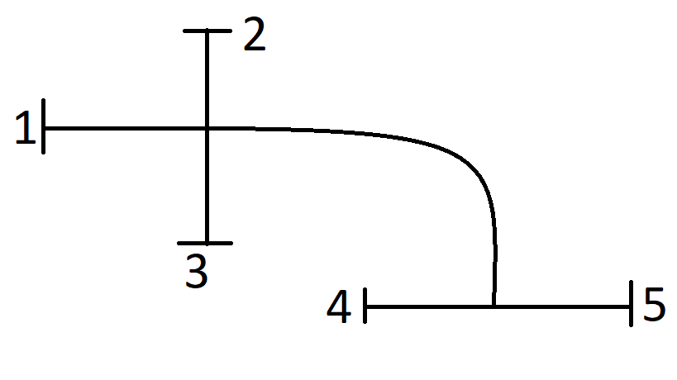

3.2.2 Diagrama de functionare a functie principale

follow_line(); move_forward(); follow_line(); stop();

follow_line(); move_forward(); follow_line(); move_left(); follow_line(); stopp();

follow_line(); move_forward(); follow_line(); move_right(); follow_line(); stopp();

follow_line(); move_right(); follow_line(); stopp();

follow_line(); move_right(); follow_line(); stopp();

follow_line(); move_left(); follow_line(); stopp();

Cazul: 23

Cazul: 21

Cazul: 15

Cazul: 12

Cazul: 14

Cazul: 13

Initializare parametrii;

Cazul: 31

follow_line(); move_left(); follow_line(); move_left(); follow_line(); stopp();

follow_line(); move_left(); follow_line(); move_right(); follow_line(); stopp();

Cazul: 25

Cazul: 24

follow_line(); move_left(); follow_line(); stopp();

follow_line(); move_left(); follow_line(); move_forward(); follow_line(); stopp();

Cazul: 41

Cazul: 35

follow_line(); move_right(); follow_line(); move_right(); follow_line(); stopp();

follow_line(); move_right(); follow_line(); move_right(); follow_line(); stopp();

Cazul: 34

follow_line(); move_forward(); follow_line(); stop();

Cazul: 32

Cazul: 51

Cazul: 45

Cazul: 43

follow_line(); move_left(); follow_line(); move_right(); follow_line(); stopp();

Cazul: 42

follow_line(); move_left(); follow_line(); move_left(); follow_line(); stopp();

Cazul: 54

Cazul: 53

Cazul: 52

follow_line(); move_forward(); follow_line(); stop();

follow_line(); move_right(); follow_line(); move_forward(); follow_line(); stopp();

follow_line(); move_right(); follow_line(); move_right(); follow_line(); stopp();

follow_line(); move_forward(); follow_line(); stop();

follow_line(); move_right(); follow_line(); move_right(); follow_line(); stopp();

Acestea sunt cele 20 de cazuri prin care se poate deplasa aplicatia, in cele ce urmeaza vor fi prezentati pasii de deplasare.

In urmatoarele situatii vom avea:

* R – move_right,
* L – move_left,
* F – move_forward.

|  |  |  |  |  |  |
| --- | --- | --- | --- | --- | --- |
|  | 1 | 2 | 3 | 4 | 5 |
| 1 | x | L | R | FR | FL |
| 2 | R | x | F | LR | LL |
| 3 | L | F | x | RR | RL |
| 4 | LF | LR | LL | x | F |
| 5 | RF | RR | RL | F | x |

Diagrama de functionare a functiei follow_line():

Initializare parametrii;

Advance();

Banda neagra centru.

Banda neagra centru

Banda neagra dreapta

Banda neagra dreapta

left(PWM);

Banda neagra stanga

Banda neagra stanga

right(PWM);

stopp();

Negru pe fiecare senzor

Memoreaza ultima directie: left()/right();

Alb pe fiecare senzor

3.2.3 Implementare software